**Online Courier Service Management**

**Introduction:** Courier Management System is a software for the cargo offices where the customer can approach the office and book an article or good. The manager/clerk can use this software to enter the details of the customer and goods along with the source and destination points. The details sundarban courier the goods into the physical transport system are also recorded the system. The system has GUI(graphical user interface) for the users to manage not only daily transactions but also to keep the historical data in the database for future reference.

**Problem definition:** The Organization was holding the system where the records in the database were not completely secure. In the current system, where whole records were handled by various employees and the data were stored in registers and excel sheets. This results in data redundancy.

**Objective:** To carry on in Bangladesh or elsewhere the business to provide, commercialize, control, develop, establish ,handle, operate, hold, pack, organize, promote, service, supervise, represent and to act as agent , concessionaires, consultants, booking agents or deal in all types of courier activities in all its branches for collecting and delivering either by own arrangements or through representatives regents, any documents, goods, articles or things on behalf of customers from one place to another place in any part of the world and to do all incidental acts and things necessary for the attainment of foregoing objects.

**Project proposal:** The purpose of this SRS(software requirements specification) document is to provide a detailed overview of our software product, its parameters and goals. This document descries the project’s target audience, hardware and software requirements. It defines how our client, team and audience see the product and its functionality. Nonetheless, it helps any designer and developer to assist in software delivery lifecycle processes.

**Activity Planer Table And Gantt Chart:**

|  |  |  |  |  |
| --- | --- | --- | --- | --- |
| Tasks | Start | End | Days | Status |
| Meeting | *6/2* | *6/3* | 1 | Complete |
| Objective | *6/3* | *6/7* | 4 | Complete |
| Analysis requirement | *6/7* | *6/12* | 5 | Complete |
| Agree on objective | *6/9* | *6/11* | 2 | Complete |
| Feature of implementation | *6/11* | *6/15* | 4 | Complete |
| Technical requirement | *6/16* | *6/17* | 1 | Complete |
| resource plan | *6/17* | *6/21* | 4 | Complete |
| design a user interface | *6/22* | *6/24* | 2 | Complete |
| design a database | *6/23* | *6/27* | 4 | Complete |
| Database development | *6/25* | *6/29* | 4 | Complete |
| Application software | *6/24* | *7/2* | 8 | Complete |
| Dev. Complete | *7/2* | *7/5* | 3 | Complete |
| Hardware configuration | *7/5* | *7/7* | 2 | Complete |
| System Testing | *7/6* | *7/9* | 3 | Complete |
| Launch | *7/9* | *7/10* | 1 | Not started |

Project Activities List with time constraint

Meeting

Objective

Analysis req

Agree objective

Feature implementation

Technical req

resource plan

design interface

design database

Database dev

Application software

System Testing

Launch

6/2 6/7 6/12 6/17 6/22 6/27 7/2 7/7 7/12

Gantt Chart for aforementioned activities

**Interviews and questionnies:** This is considerednasnone of the best fact finding techniques. This inncludes direct interactin with the customer. It is considered as the best technique, because it is the only way the user can reveal the details & facts about his past, present & expected working, requirements, technologies, desertions to analysis. This is the information, which gives us the description of the system, we have to implement our logic & our own ideas & make this description to turn to a relity, to work as a real module, which the user desires.

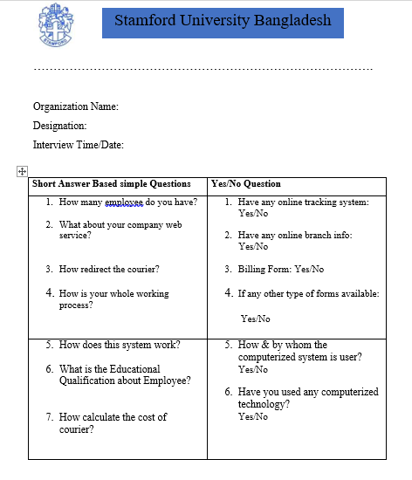

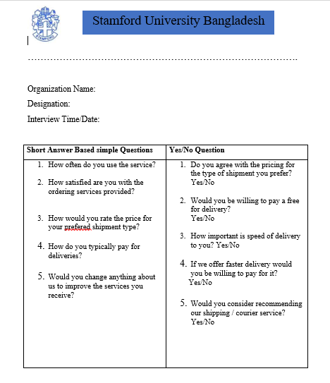

**Information Gathering and Summaries:** If I want to send our parcel to a specific location within a specific time frame, I can opt for parcel delivery services. There services ensure the safe and timely delivery of our parcel and most courier services charge according to the size and weight of the parcel. Research the market carefully and opt for a deal that is best suited t our budget. Courier services are a great way to ensure the fast and reliable delivery.

**DFD: Level 0**

Output

3

Output view and Print

1

Login and Tracking

Data Store 2

Data Store 1

Staff

2

Management Control

Customer

**DFD: Child level**

Output

1.4

Output view and Print

1.1

Login

Data Store 2

Customer

1.3

Branch Information

1.2

Tracking

**DFD: Child level**

Output

3

Output view and Print

Data Store 2

Data Store 1

Staff

2

Management Control

2

Deliver

ER-Diagram

Admin

Tracking

Manager

Staff

User

Branch

Manage

Delivery

Manage

ER-Diagram design

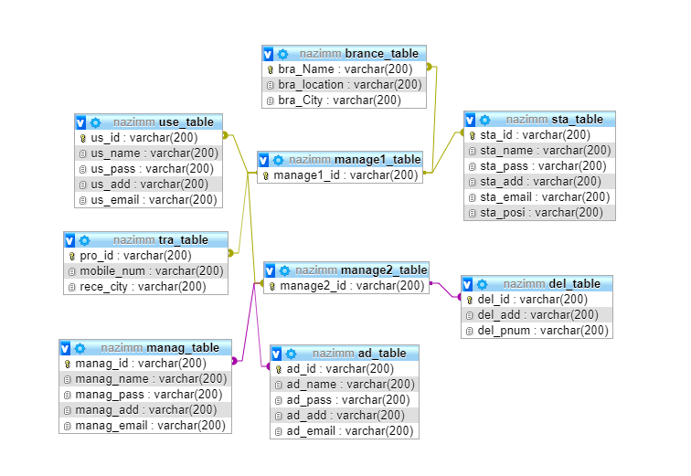

**Use case diagram**

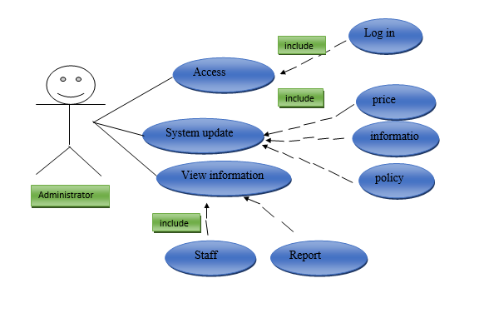

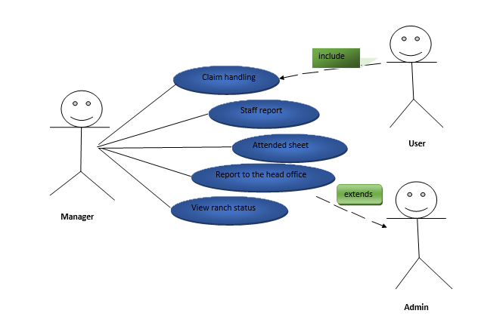

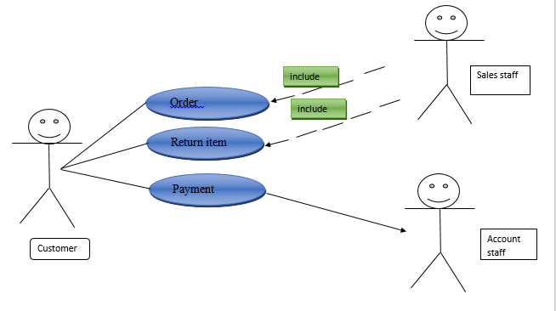

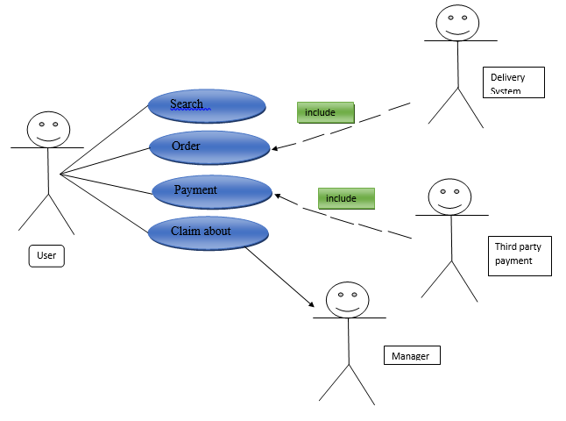

**Class Diagram**

Class Diagram : Administrator

Administrator

-id : int

-name : char

-pass : char

-email_id : char

+staff_management()

+update_price()

+update _info()

+update_policy()

User

Staff

Manager

-id : int

-name : char

-pass : char

-email_id : char

-address : char

-id : int

-name : char

-pass : char

-email_id : char

-address : char

-position : char

-id : int

-name : char

-pass : char

-email_id : char

-address : char

+Tracking()

+Branch_info()

+Home_taken()

+Redirect_dest()

+update()

+Receeive()

+Data_entry()

+Delivere()

+Attendence()

+Staff_report()

+claim_handleu()

+Report_admin()

Class Diagram : Manager

+Attendence()

+Staff_report()

+claim_handleu()

+Report_admin()

-id : int

-name : char

-pass : char

-email_id : char

-address : char

Manager

Class Diagram : Staff

Staff

-id : int

-name : char

-pass : char

-email_id : char

-address : char

-position : char

+Receive()

+Data_entry()

+Deliver()

Customer Care Manager

General Staff

Account Manager

-id : int

-name : char

-pass : char

-email_id : char

-address : char

-id : int

-name : char

-pass : char

-email_id : char

-address : char

-id : int

-name : char

-pass : char

-email_id : char

-address : char

+Feedback()

+Solution()

+Report()

+Payment()

+Transaction()

+Report()

+Receive()

+Data_entry()

+Deliver()

+Report()

Class Diagram : User

User

-id : int

-name : char

-pass : char

-email_id : char

-address : char

+Tracking()

+Branching_info()

+Home_taken()

+Redirect_dest()

+update()

General User

Feedack

Registered User

-id : int

-name : char

-pass : char

-email_id : char

-address : char

-id : int

-name : char

-pass : char

-email_id : char

-address : char

+Branch_info()

+Home_taken()

+Chat room()

+Remark()

+Track()

+View_status()



